**IA – 1 (SET-B)**

**TITLE – Language Learn**

|  |  |
| --- | --- |
| **Name: Prachi Gandhi** | **Roll No.: 16010422233** |
| **Name: Chandana Galgali** | **Roll No.: 16010422234** |

**Problem statement:**

A language-learning app that uses gamification to make learning fun and engaging. Features include gamified lessons, daily streaks, points, badges, and leaderboards.

**Abstract: (Describe what exactly have you covered in the IA)**

This project is for designing a UI for “Language Learn” using Figma, with the objective of making the app more fun and accessible for users. The design takes users through guided lessons and progress tracking, among others, with five major UI patterns included: Clear Entry Points, Modal Panel, Escape Hatch, Sequence Map, and Sign-in Tools. Each element has been crafted with care so that users can easily find their way and use applications without getting lost, hence making the learning process of a new language a true interactive journey.

**What is information architecture?**

Setting up information architecture is just like setting up a house; it's where every room has a purpose, and everything flows smoothly. In “Language Learn”, through the use of information architecture, the content will be laid out in such a way that users can flow through finding lessons, tracking progress, and enjoying the learning process. This design will make sure at all times that users know exactly where they are and where to head next, by keeping things simple and intuitive.

**What is a site structure?**

The site structure is basically a roadmap to the app; it connects all the different sections, guiding a user from one end of the app to another, say from lessons back to his profile or leaderboard. In “Language Learn”, he will be taken through a learning progress within the course: a lesson started, achievements are reviewed, or maybe jumped to the dashboard.

**Explain navigation models (for set b).**

Navigation models determine how users interact with and move through the app. Here’s how each pattern is applied in “Language Learn”:

1. **Clear Entry Points:** The frame that satisfies the “Clear Entry Points” pattern is the “Home” page. It allows users to get right into an application by providing options to “Start Learning”, “Continue Learning”, and “Explore Lessons” directly on the front page. A hamburger icon opens a side navigational menu opening to additional features, while the profile icon takes them to the dashboard. Users can also view their “Current Streak”, track their progress in “Daily Challenges”, and swipe through engaging slides that offer a quick “Word of the Day”, “Learning Tips”, “Fun Facts”, “Phrase of the Day” and a “Quick Challenge” to reinforce learning.
2. **Modal Panel:** When the user reaches a milestone, a modal panel (overlay) shows up with a message such as “Hooray! You entered the Silver League!”. This will keep the user motivated and engaged because their progress is acknowledged right away.
3. **Escape Hatch:** Each lesson also has a “Save Progress & Exit” button at the bottom. This will give the user a little leeway in case they have to stop their lesson midway, saving their place and then resuming later or starting back at the home screen.
4. **Sequence Map:** The onboarding process follows a sequence map wherein each stage is visually marked, like “Language”, “Level”, “Reason”, “Goal” and “Age”. This gives the user an idea where they are in the onboarding process and makes it exciting and easy to understand.
5. **Sign-in Tools:** The sign-in page of an application is minimalistic and provided with choices for quick ways of signing in, such as “Sign in with Google” etc., which allows for smooth registration and ensures that users of an application get into utilizing the application quickly without bothering them with long forms.

**WIREFRAME DESIGNS:**

**Attach screenshots of your design with clear and concise explanation of each image.**

**Also explain what patterns/models have you used in each screen. (Minimum 5 patterns expected)**

1. **Clear Entry Points:**

The home page features three main buttons—“Start Learning”, “Continue Learning” and “Explore Lessons”—that help users begin their learning journey. A hamburger menu opens a side navigation panel, allowing access to options like “Dictionary”, “Podcasts”, “Shop”, “Chat”, while the profile icon takes the users to their dashboard. Users may also view their “Current Streak”, track their progress in “Daily Challenges” and flip through engaging slides with a quick “Word of the Day”, “Learning Tips”, “Fun Facts”, “Phrase of the Day” and a “Quick Challenge” to improve learning experience.

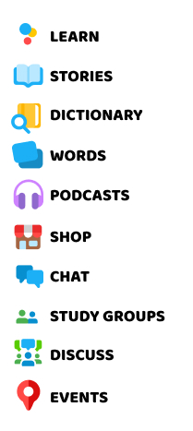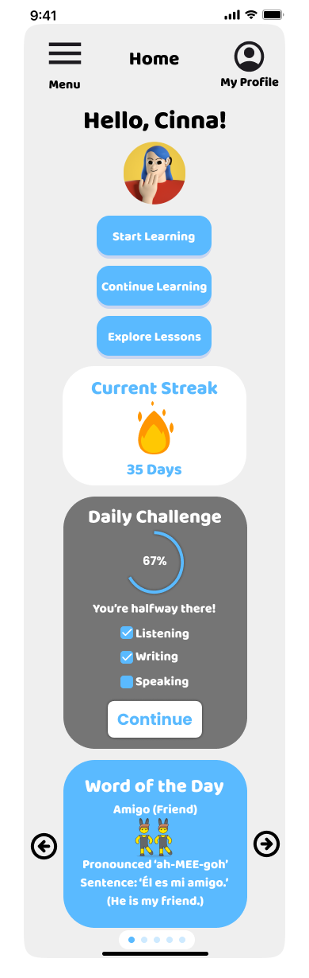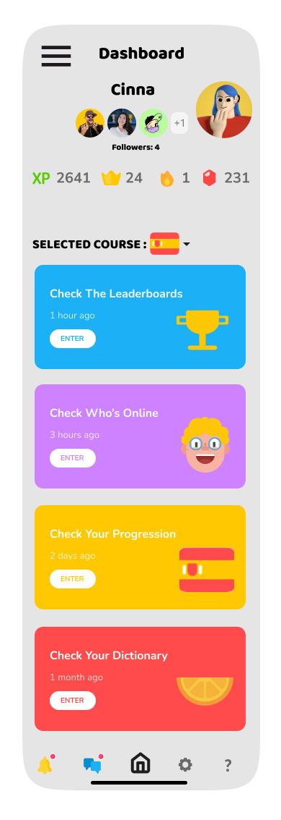

Home Page gives a Clear Entry Point as shown below.

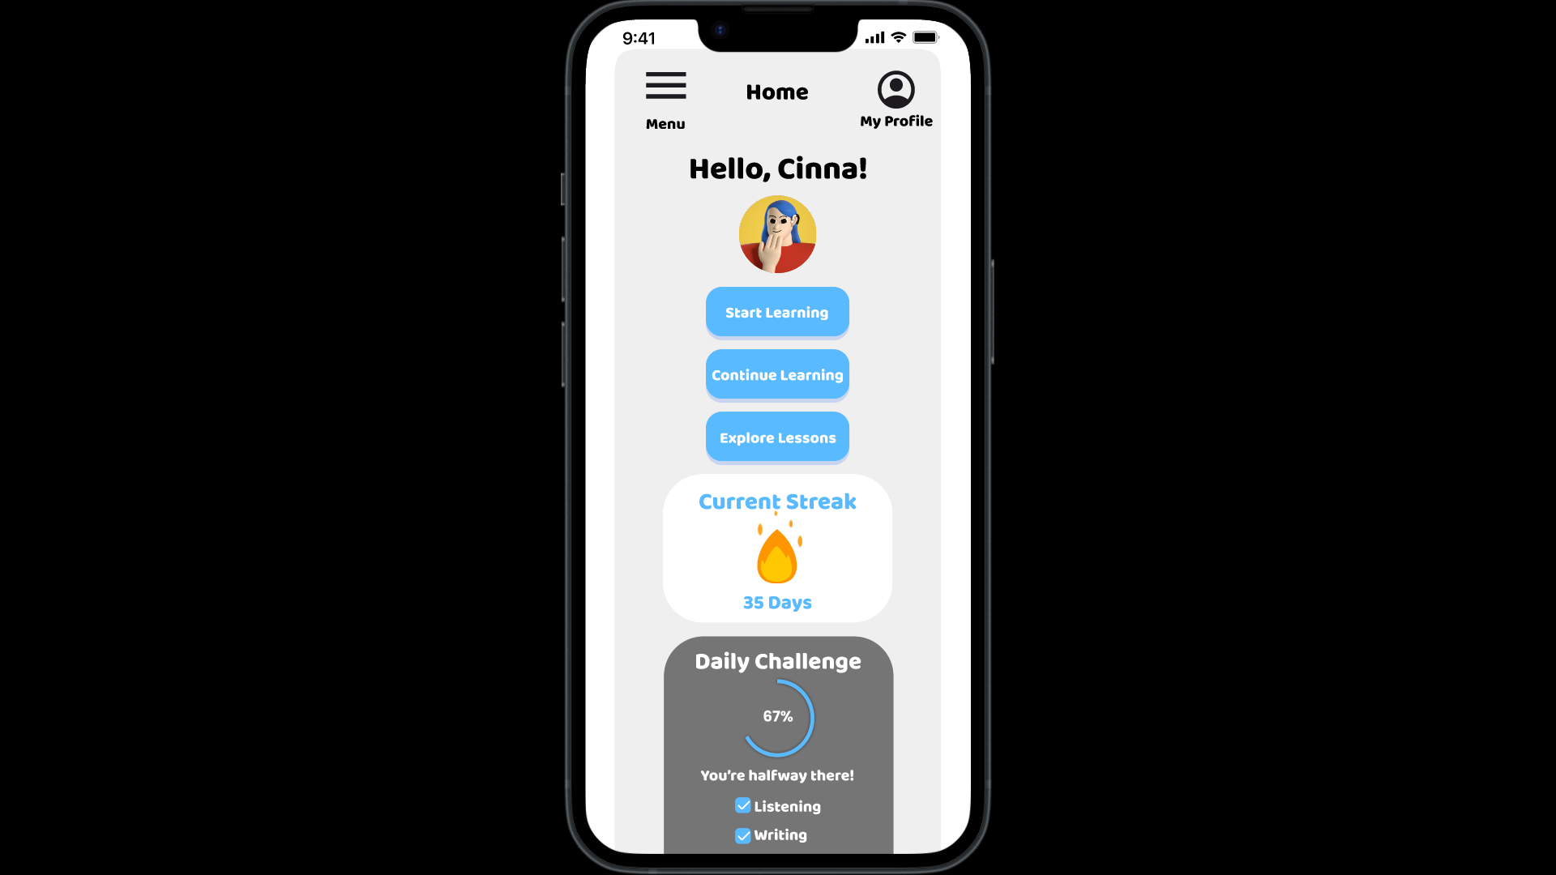

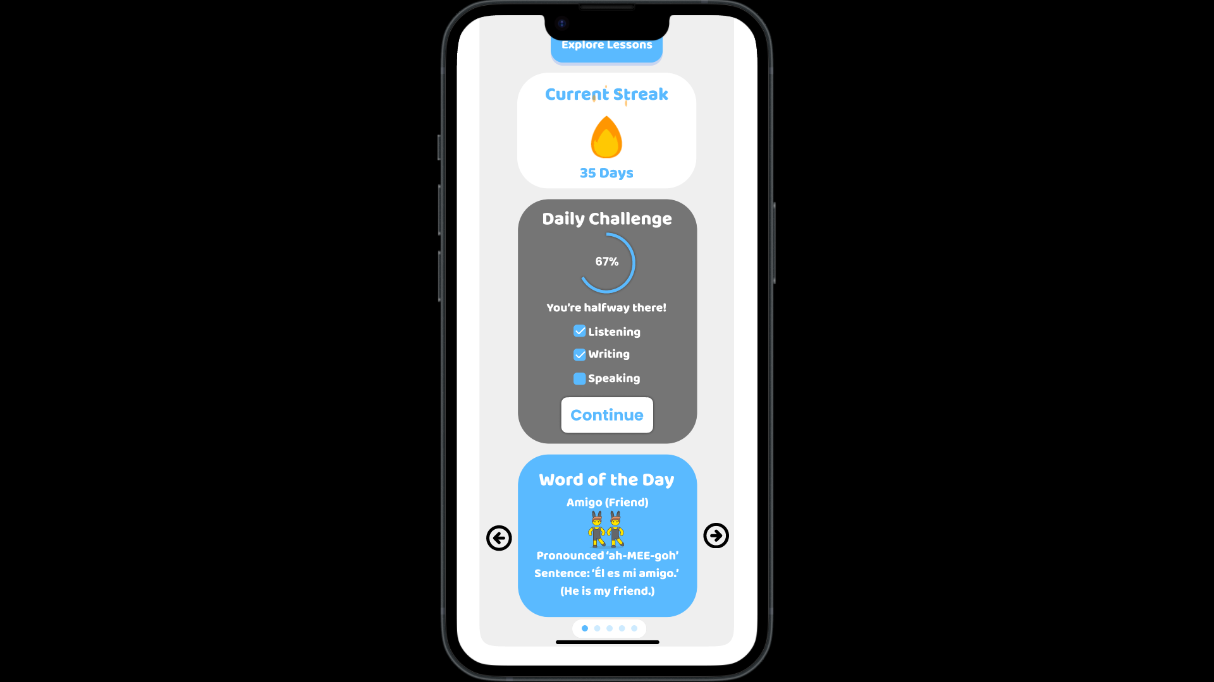

On clicking “Menu”, a side navigation panel appears as shown below.

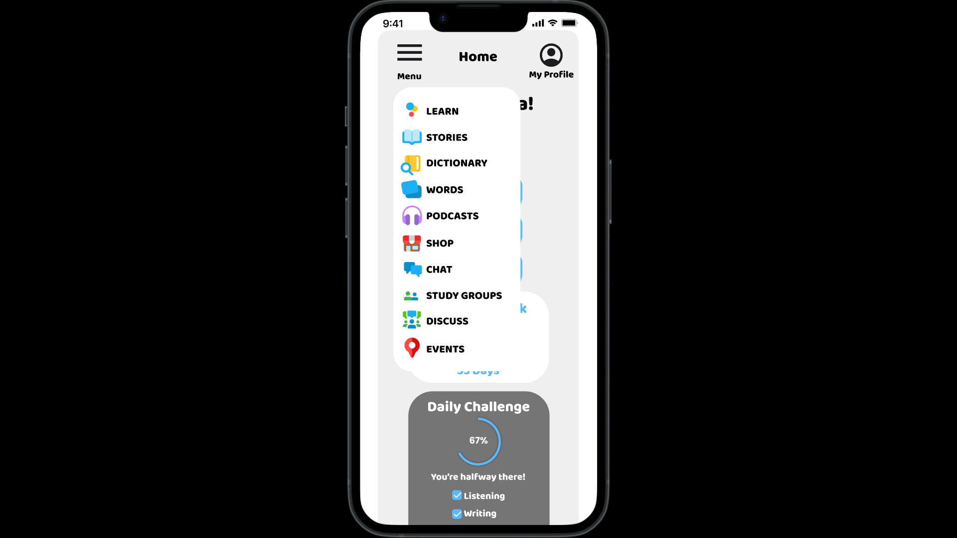

On clicking “My Profile”, the user is navigated to their dashboard.

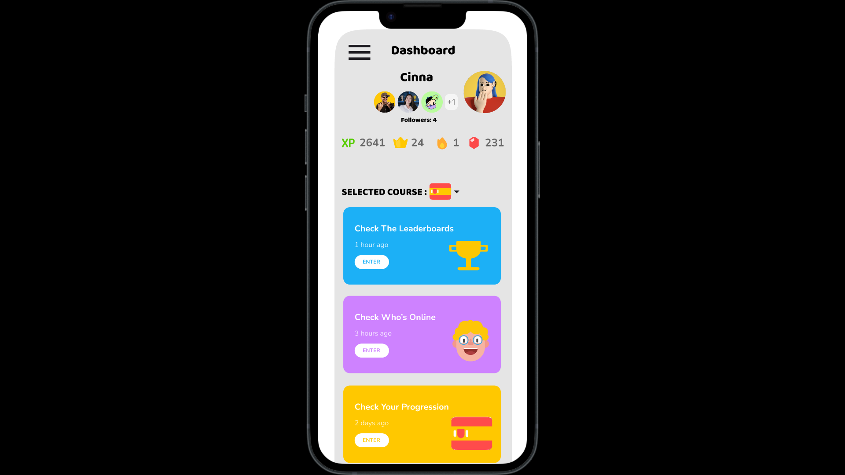

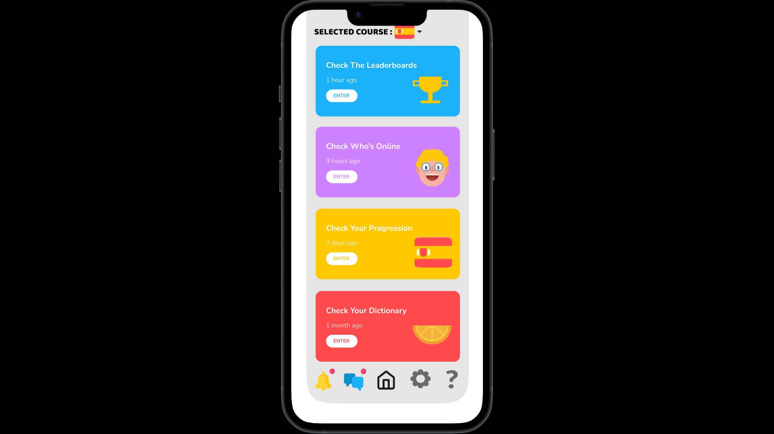

On clicking “Start Learning”, the user is navigated to the lesson window.

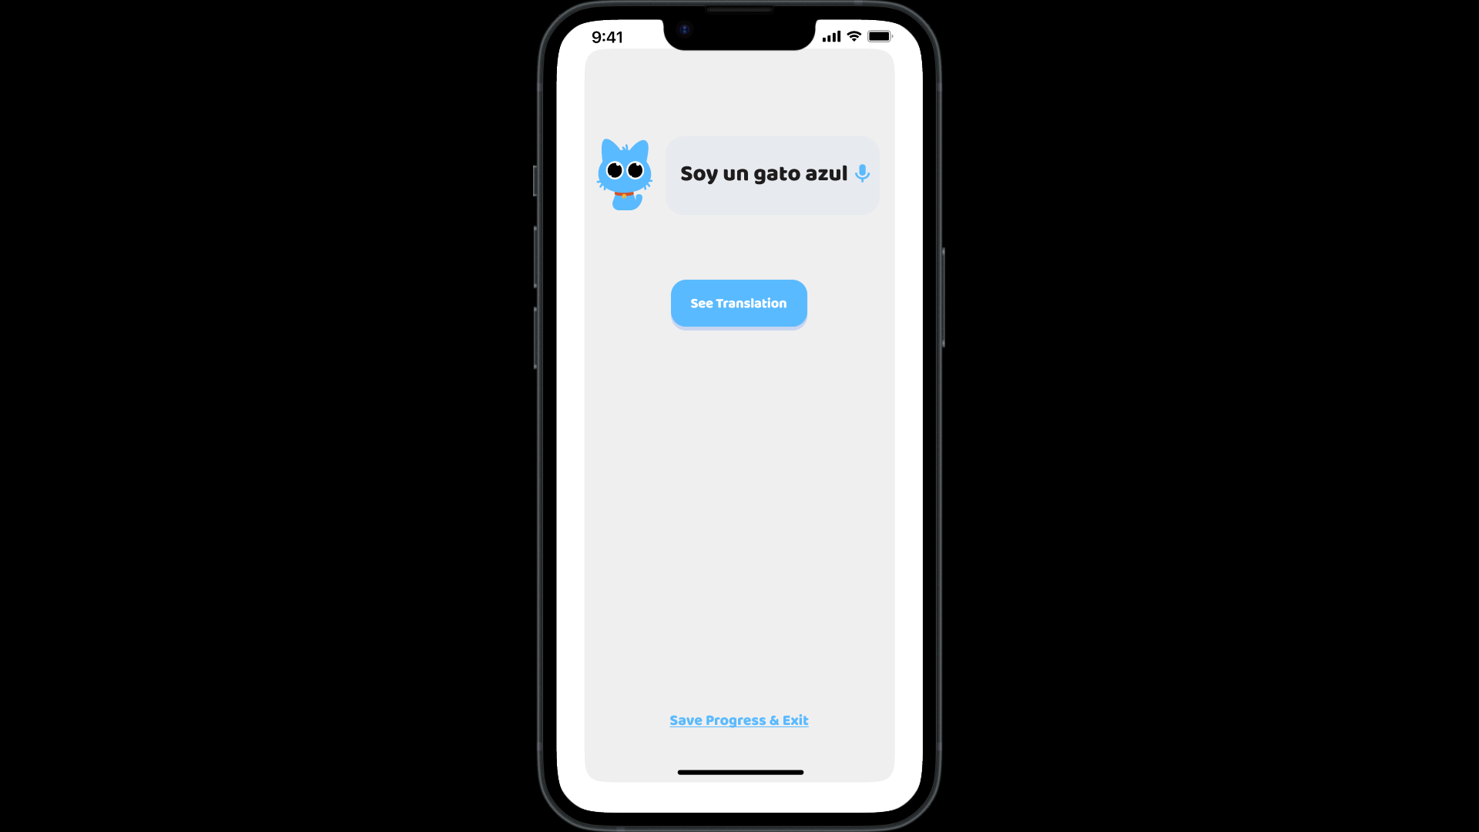

On clicking “Continue Learning”, the user is taken back to the section of the lesson where they stopped and did not complete the sections following.

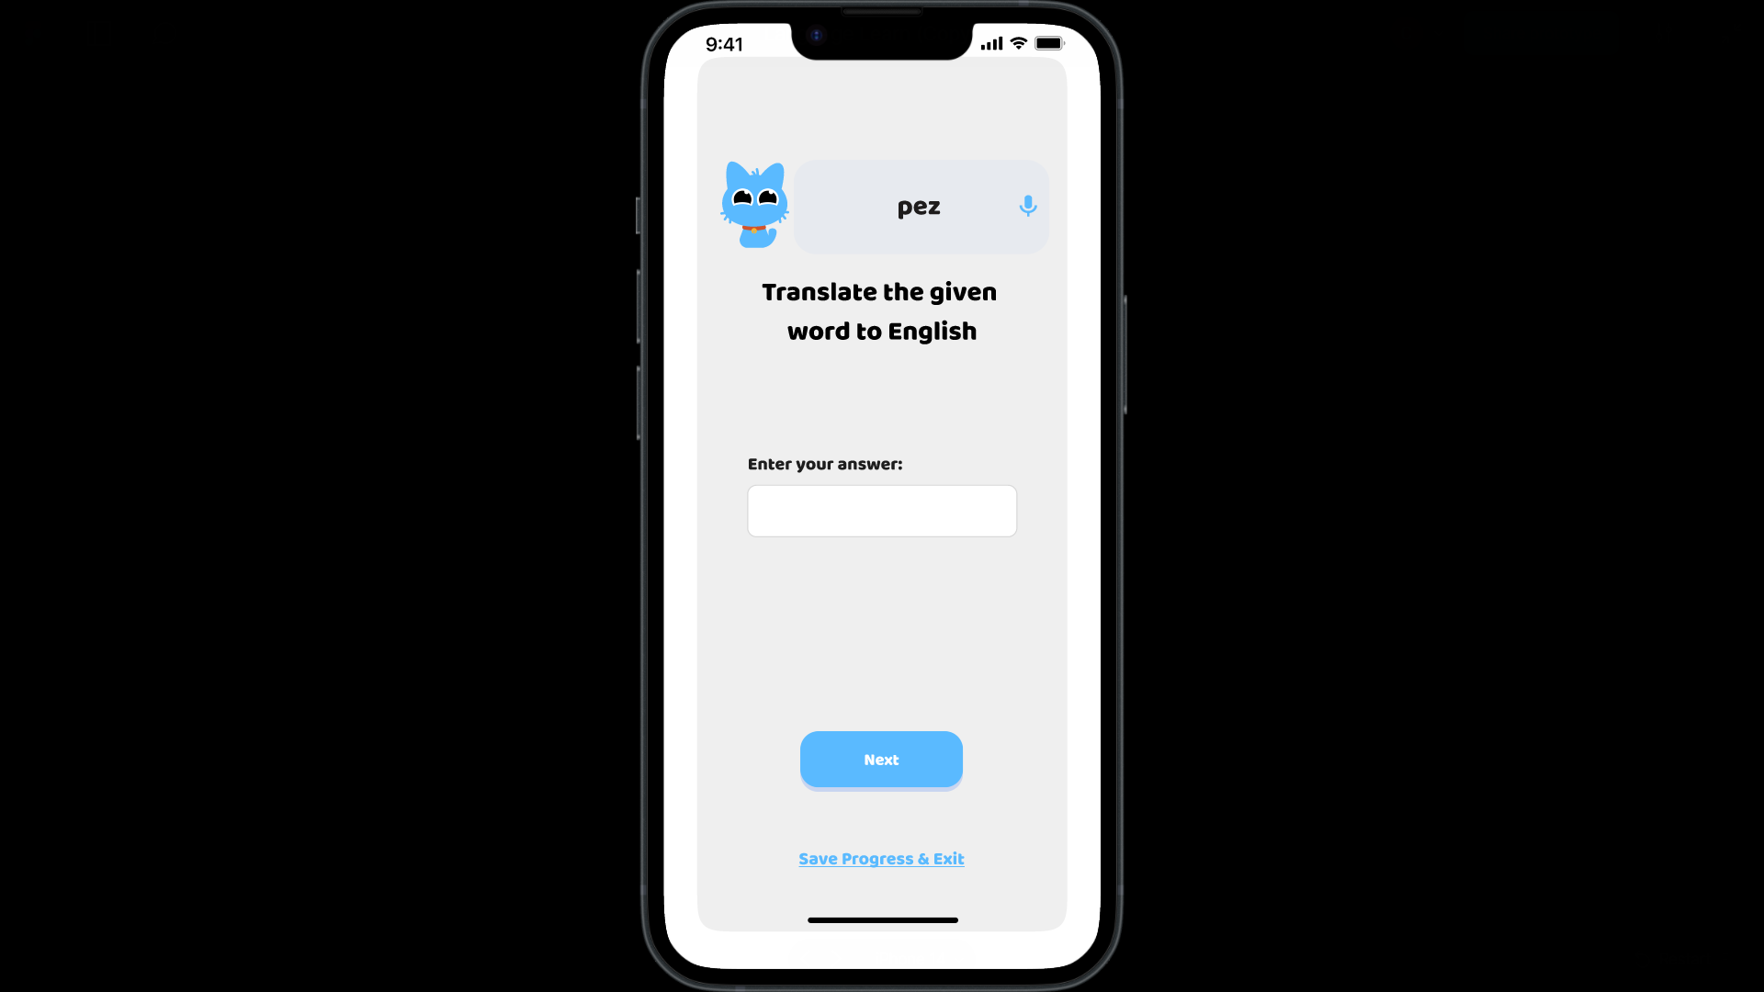

On clicking “Explore Lessons”, the user can see the list of all the lessons and their progress in each lesson.

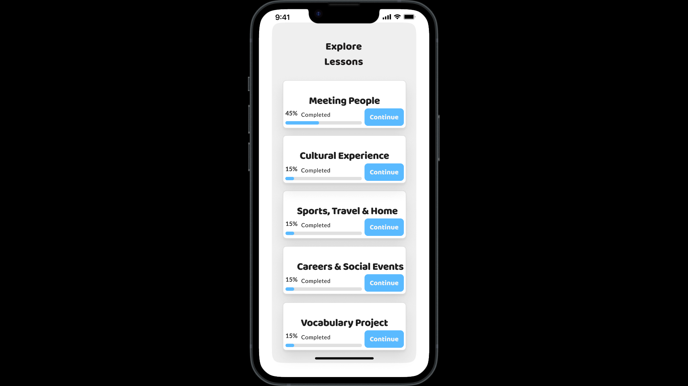

On clicking “Continue” in the “Daily Challenges” section, the user is navigated to the remaining sections that need to be finished by the user to complete the daily challenge.

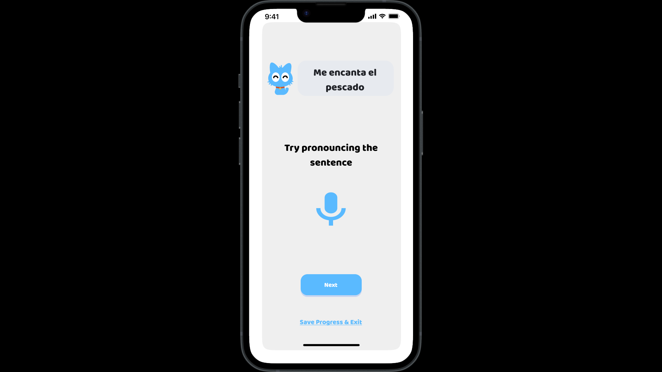

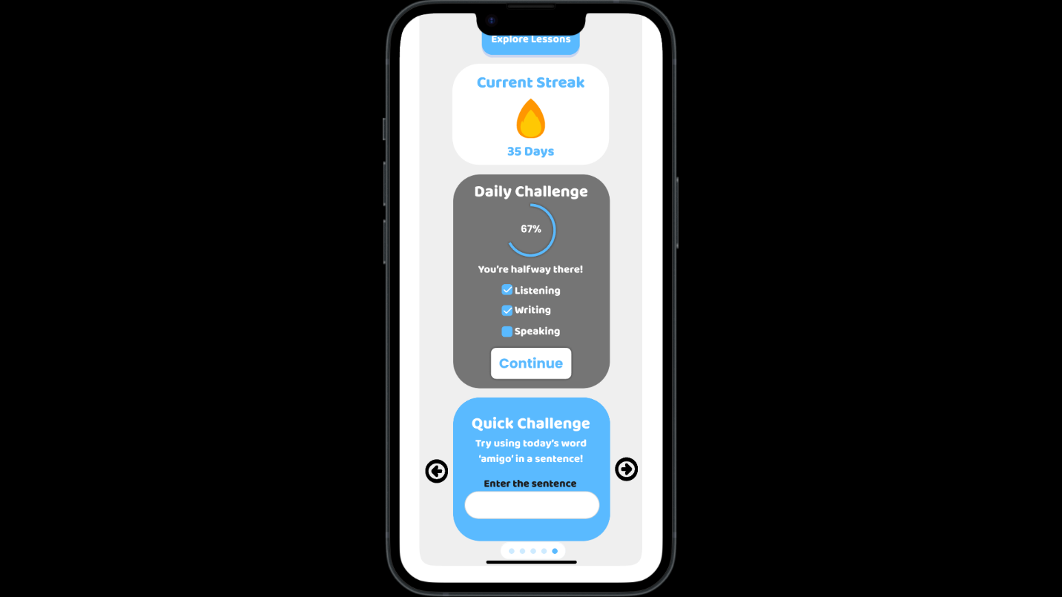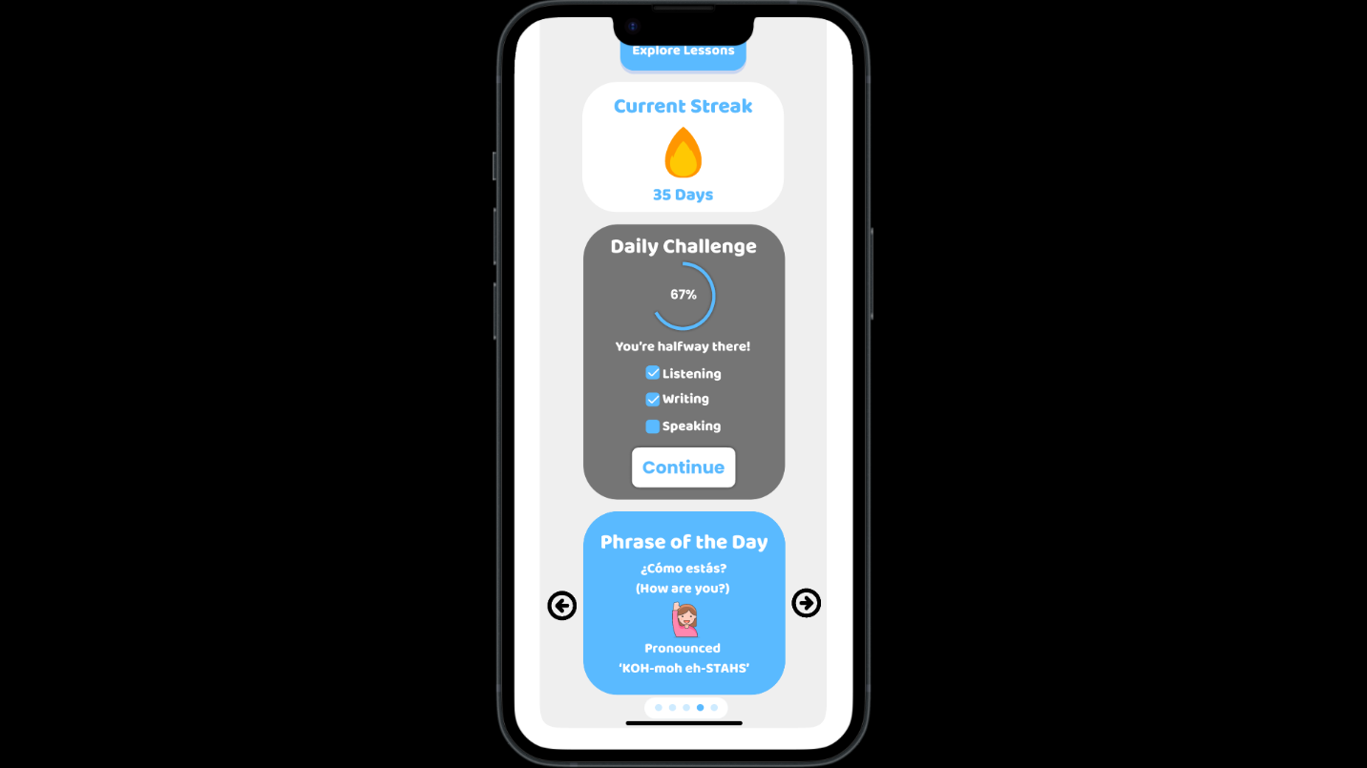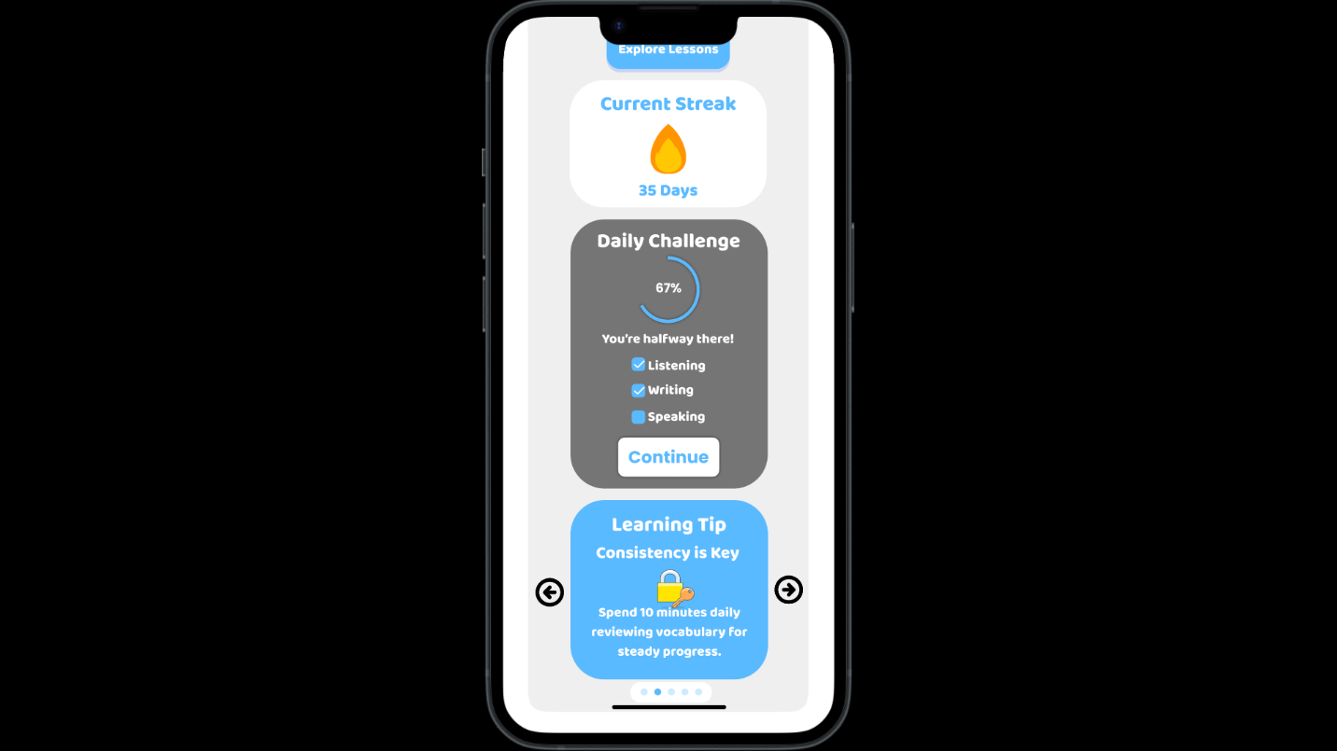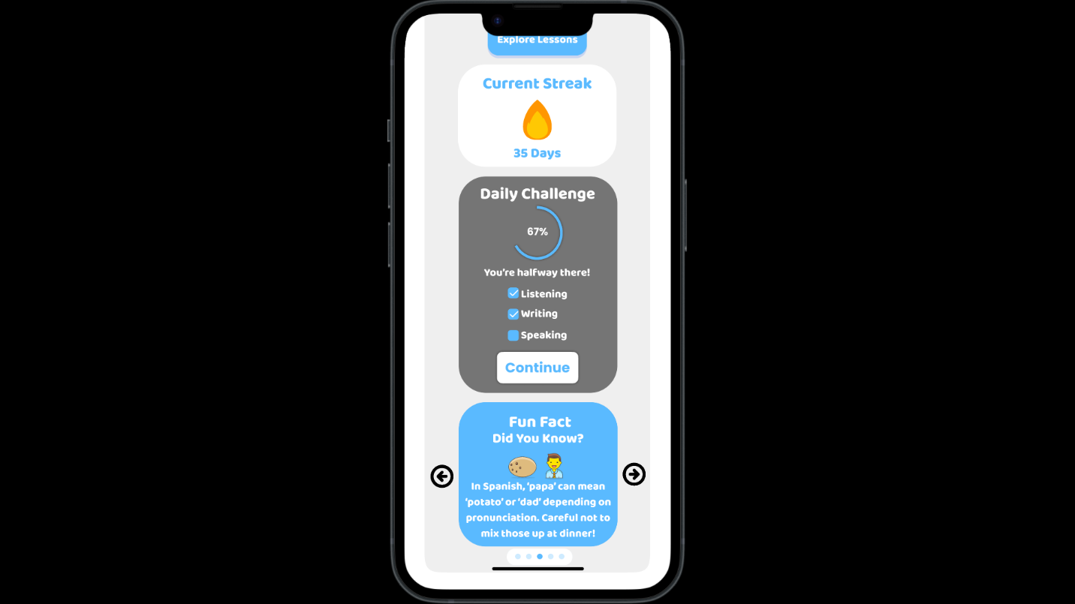The slideshow at the bottom of the page offering engaging slides to the user.

1. **Modal Panel:**

When a user achieves something significant, like completing a lesson, an overlay appears with a message such as “Hooray! You entered the Silver League!” This creates a sense of accomplishment and encourages users to continue their progress.

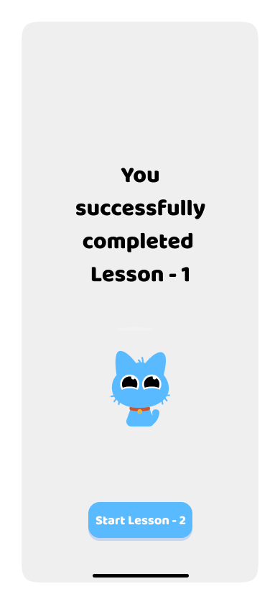

After completing Lesson-1, a screen appears to inform the user the same.

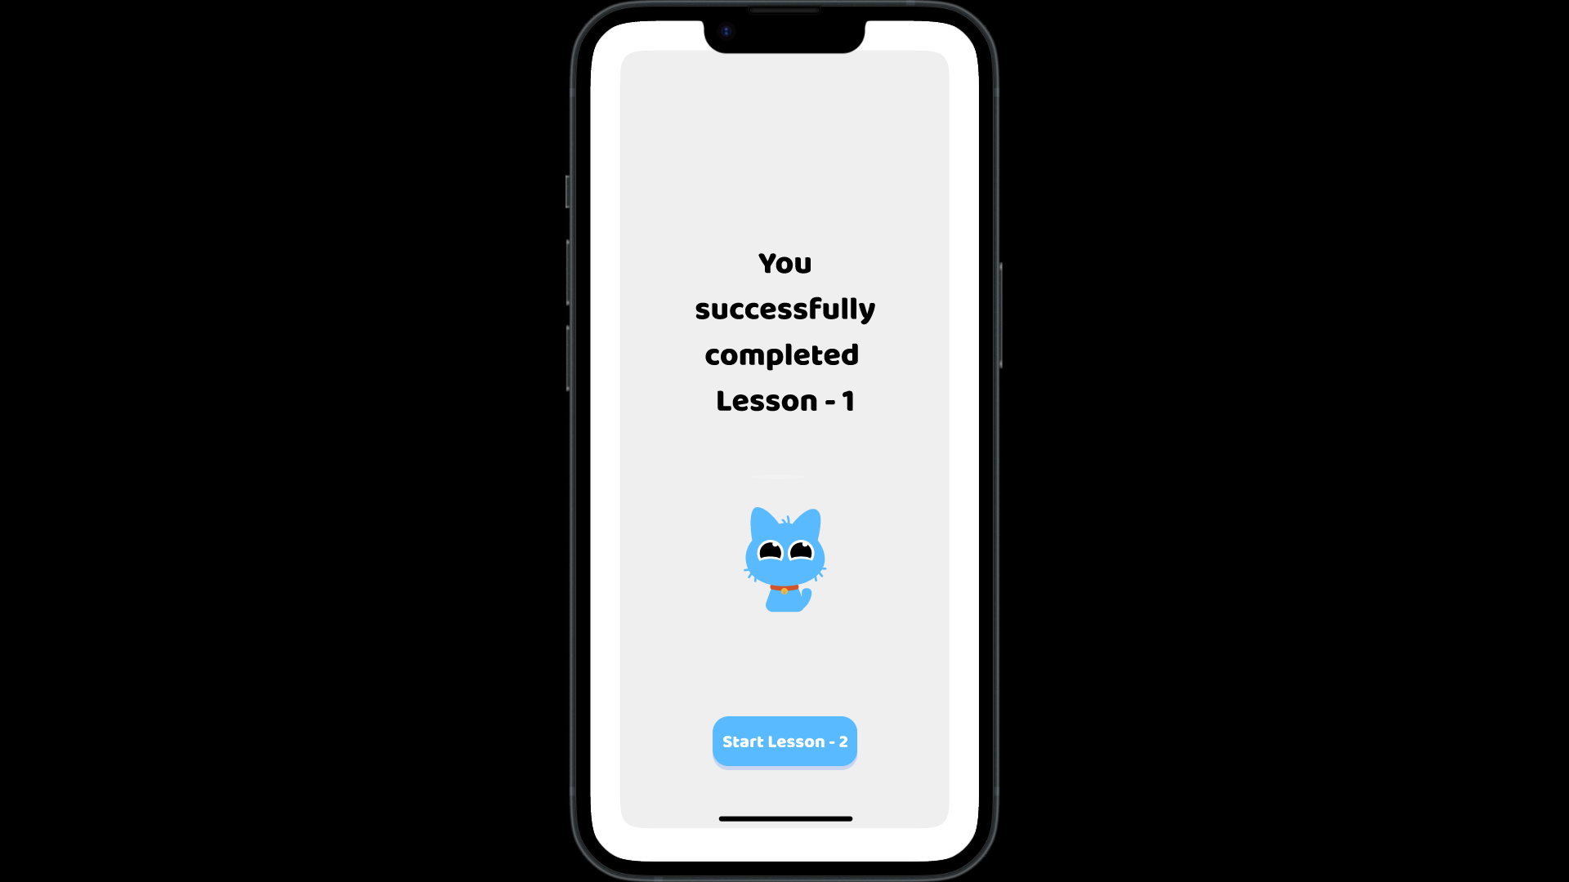

After a delay of 1500ms, a modal panel appears as shown below to notify the user of their achievements, in this case, entering a new league.

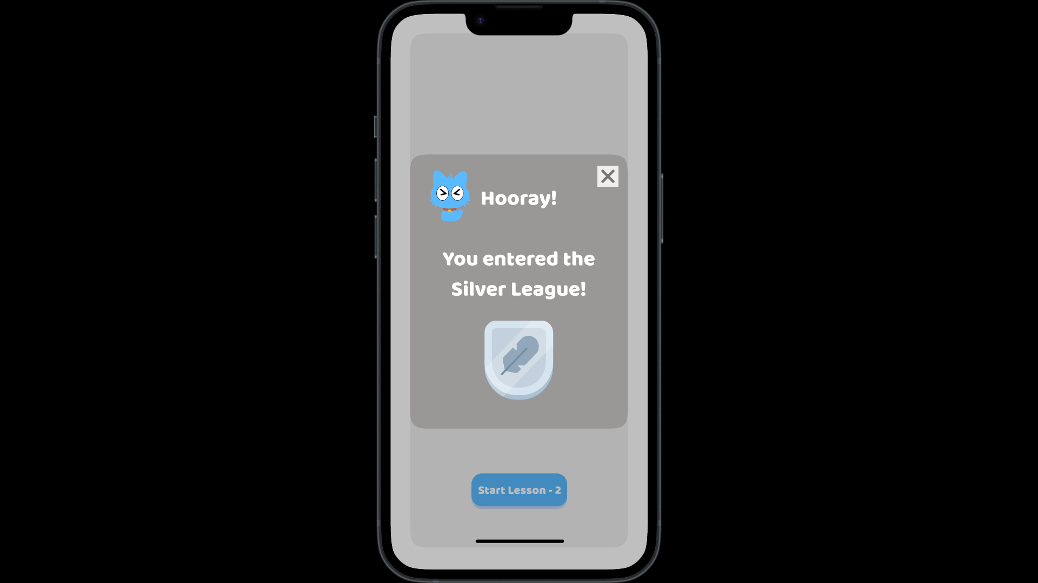

1. Escape Hatch:

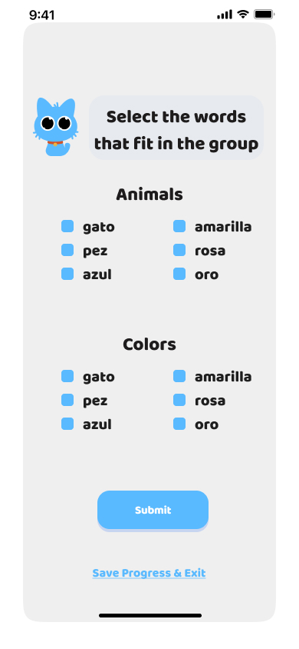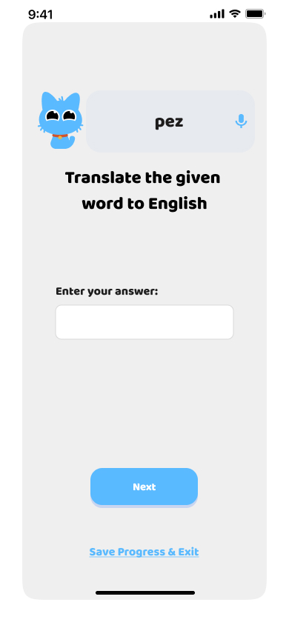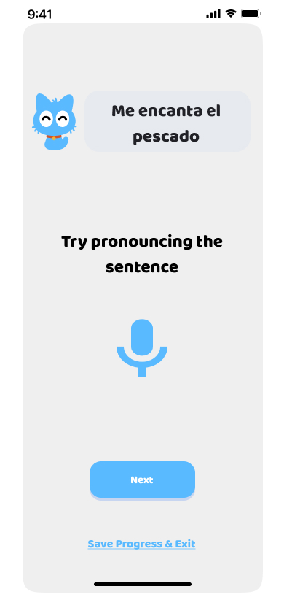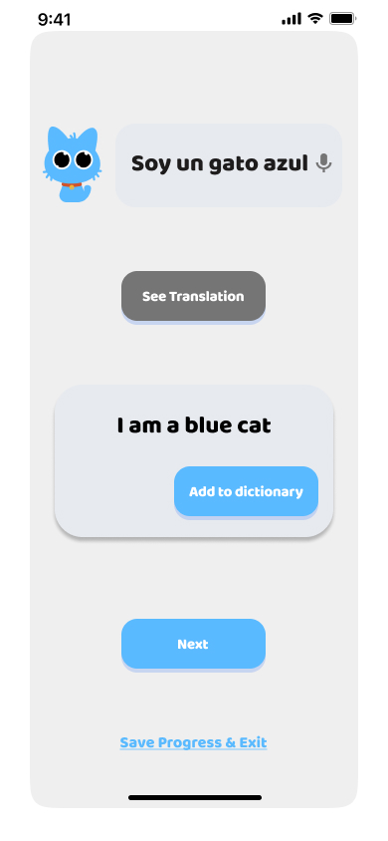During lessons, users can opt to “Save Progress & Exit” using a button at the bottom. This triggers a modal offering choices to either resume where they left off or return to the home page. This feature provides flexibility for users to manage their time effectively.

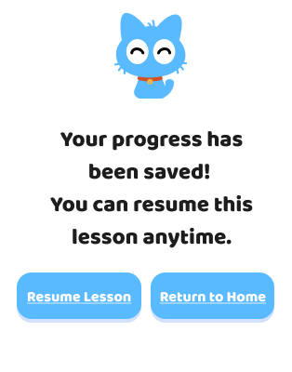

Suppose the user has reached the following section of the lesson;

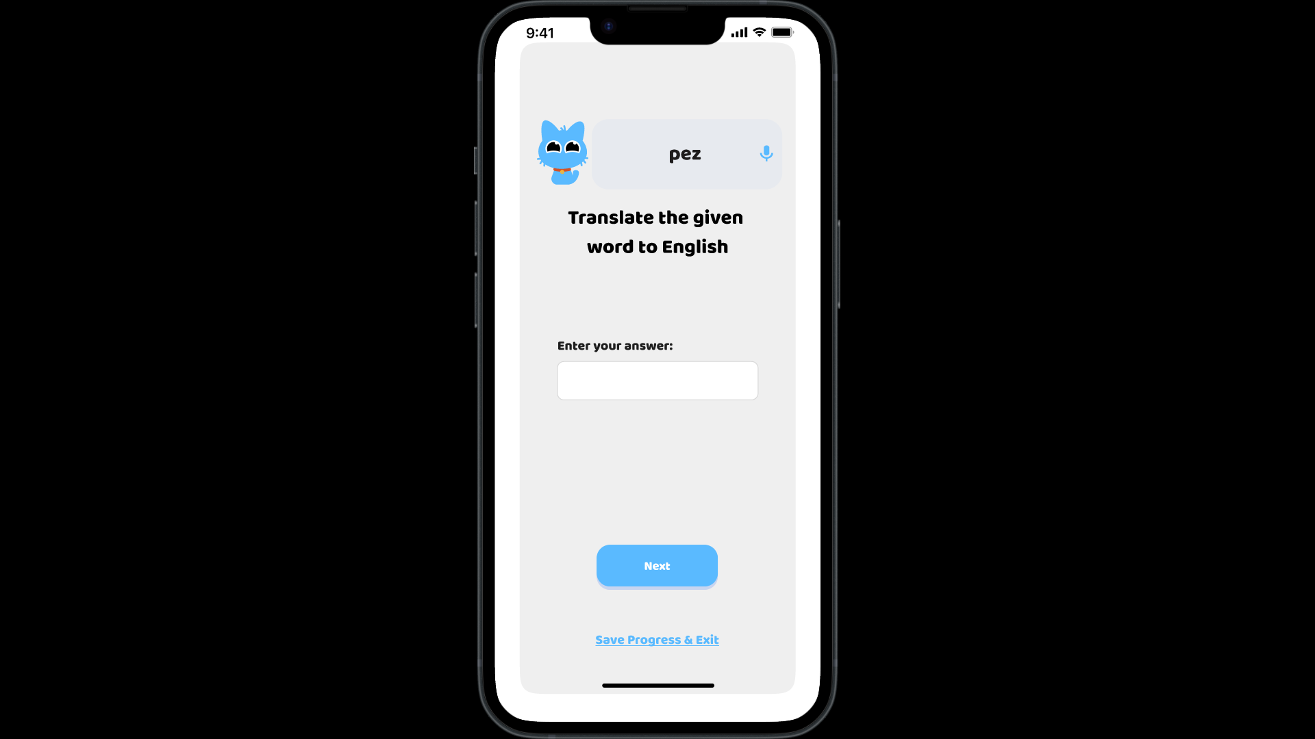

On clicking “Save Progress & Exit”, an overlay as shown below appears.

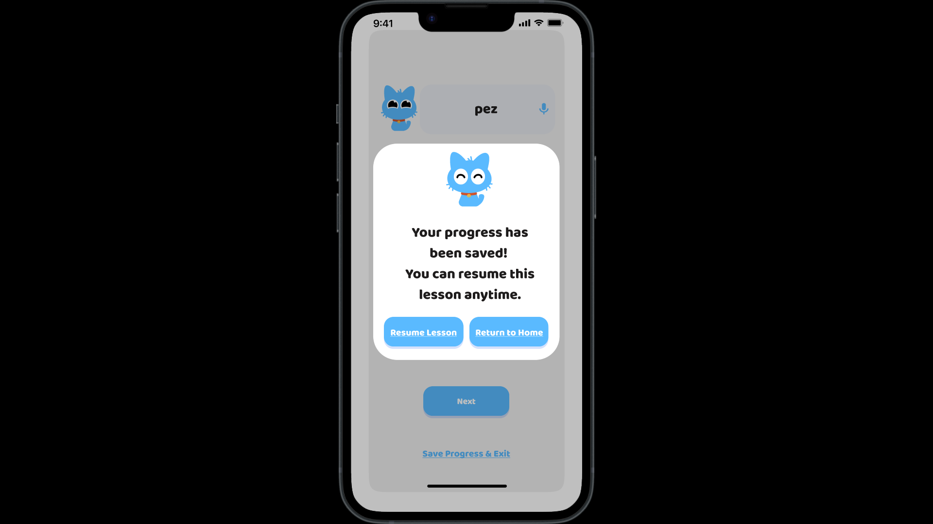

On clicking “Resume Lesson”, the user can continue the lesson.



On clicking “Return to Home”, the user can return back to the “Home” page.

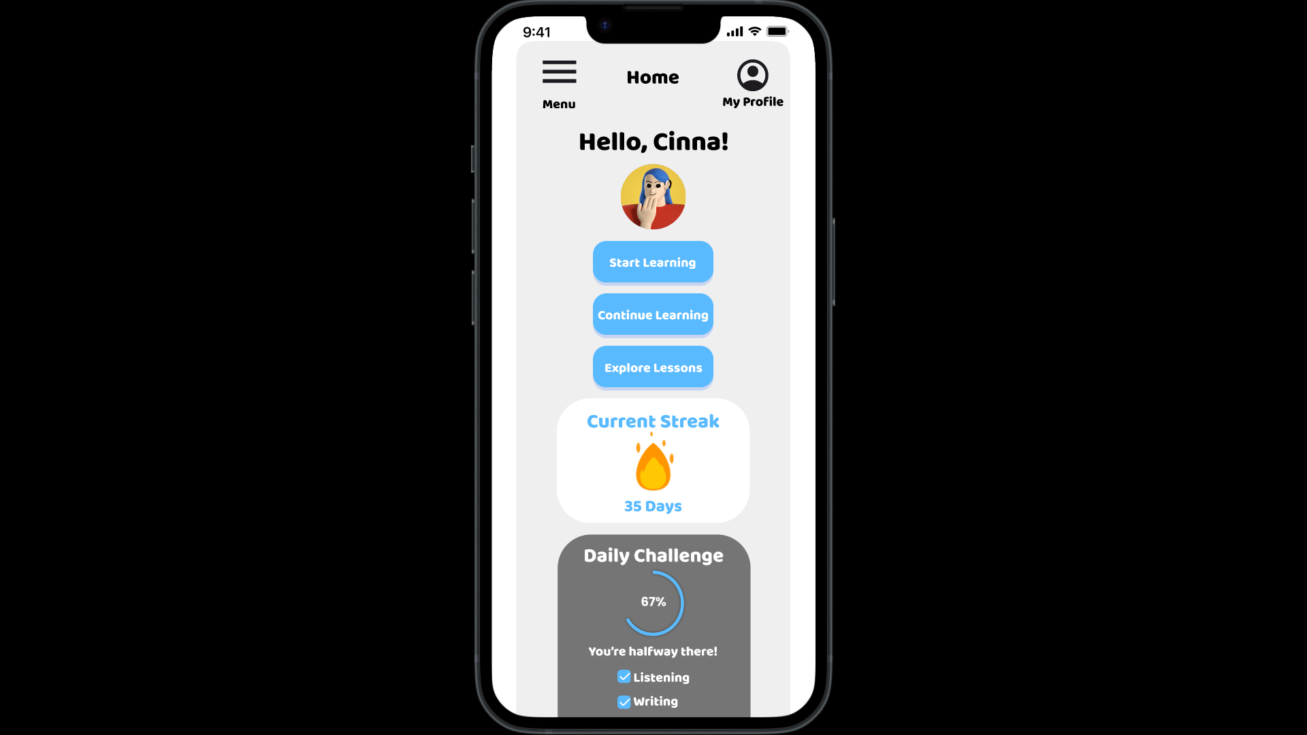

1. Sequence Map:

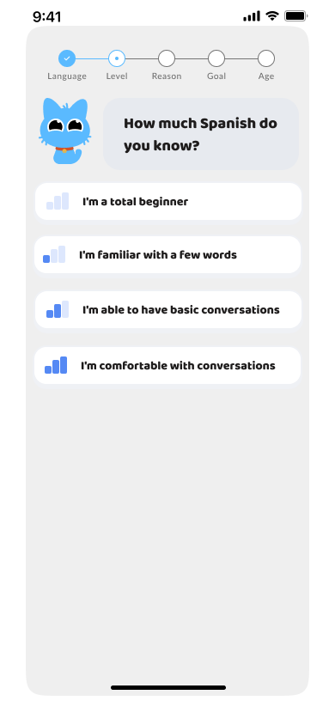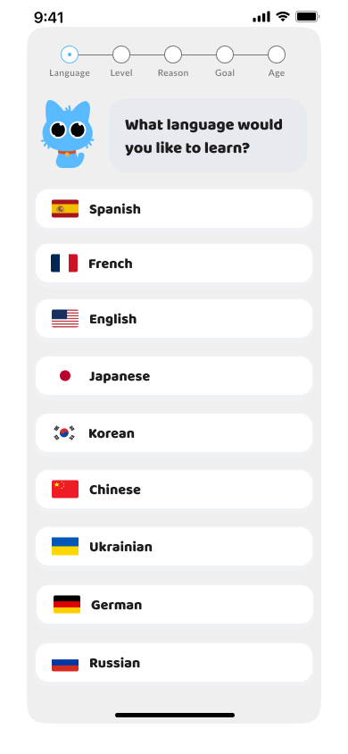A progress indicator is displayed at the top of the setup screens, guiding users through steps like selecting their “Language”, “Level”, “Reason”, “Goal” and “Age” for learning. It helps users understand their progress through the initial setup.

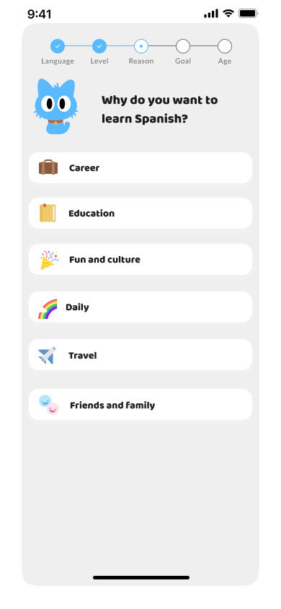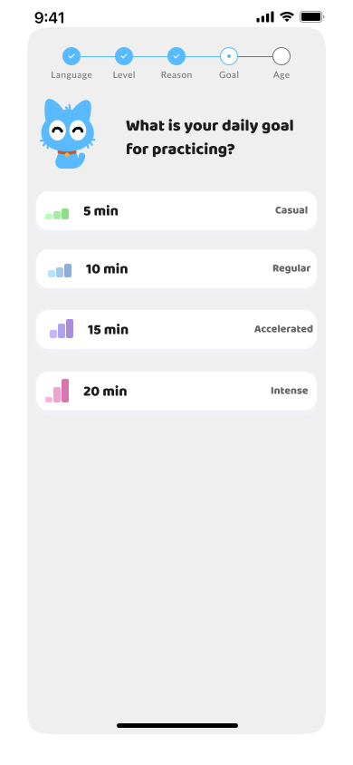

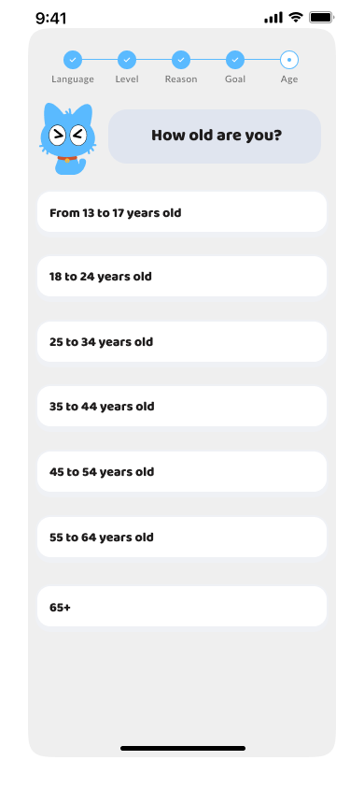

On starting the setup, the user is asked to choose the language they want to start learning first.

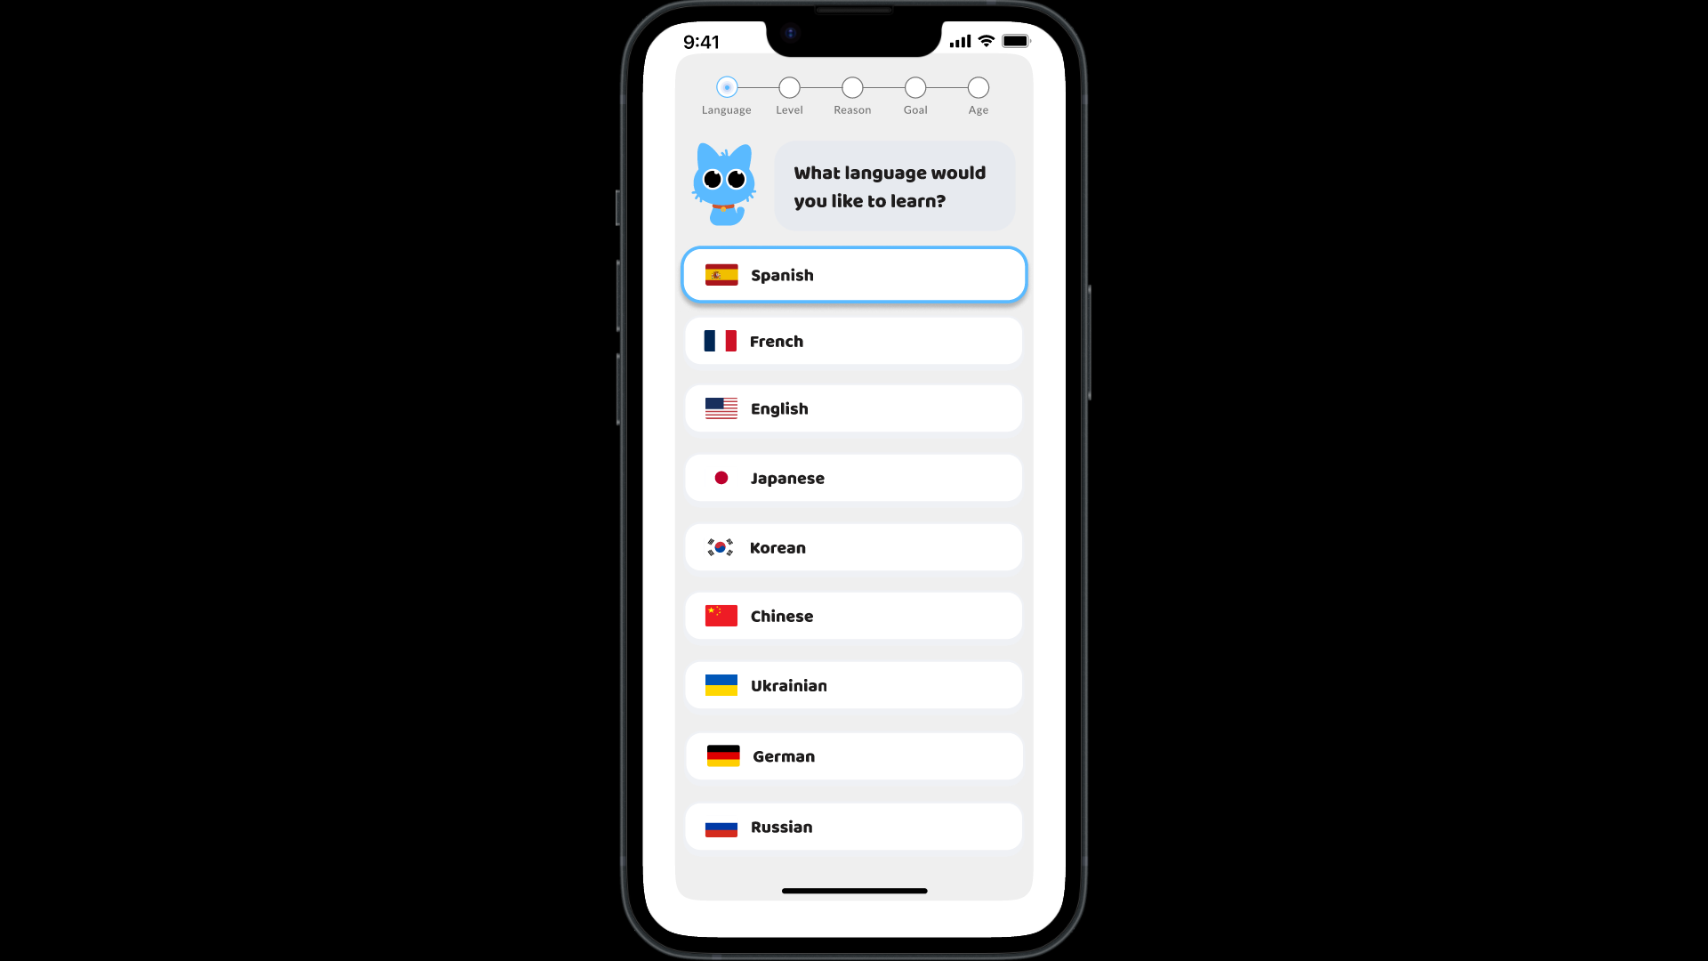

After choosing the language, the level of familiarity with the language is asked.

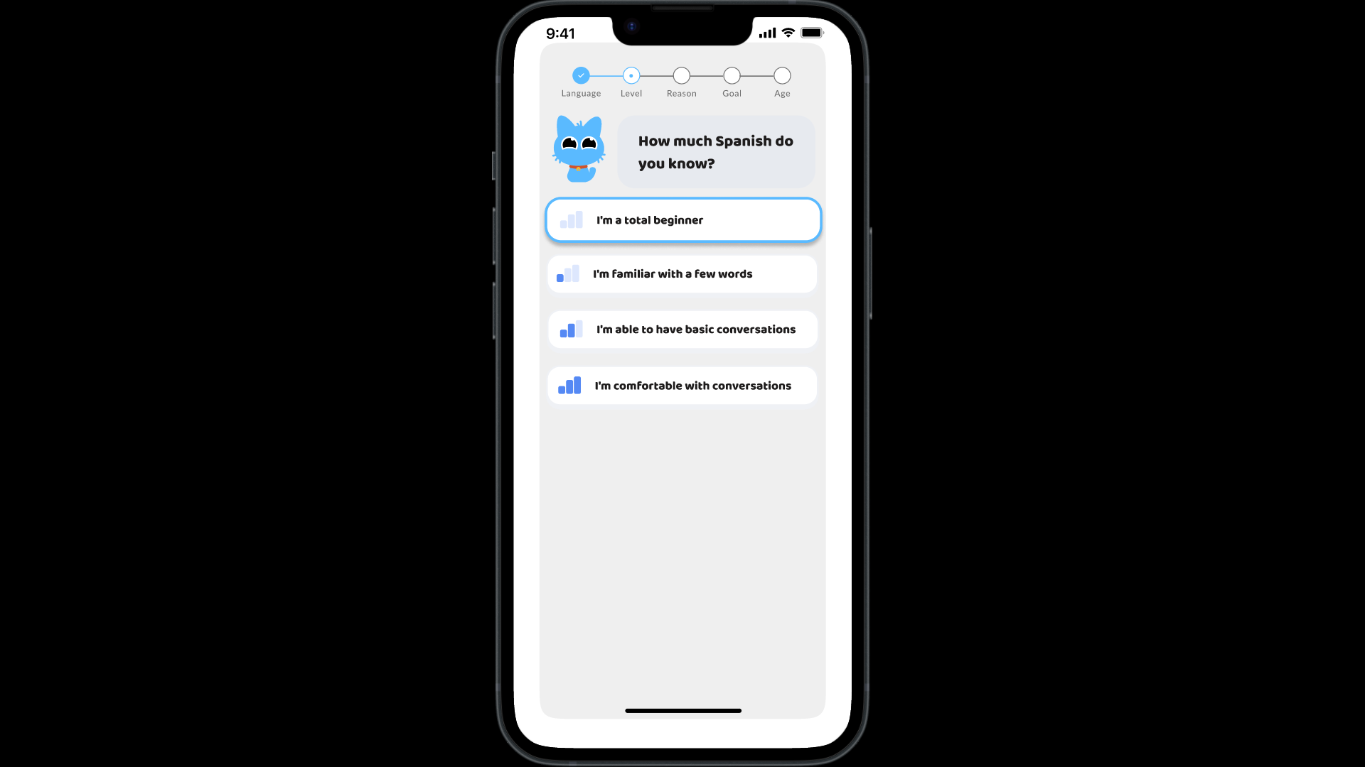

After choosing the level, the reason/context for studying the language is asked.

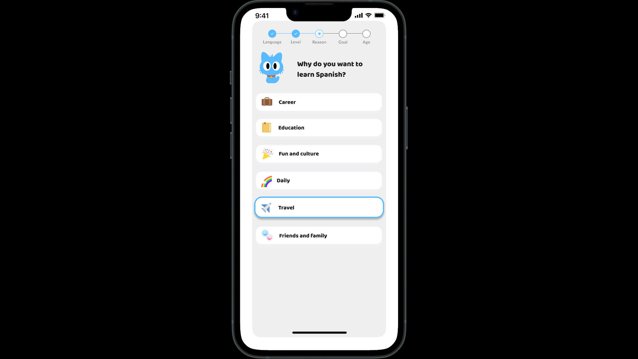

After choosing the reason, the user’s goal is asked.

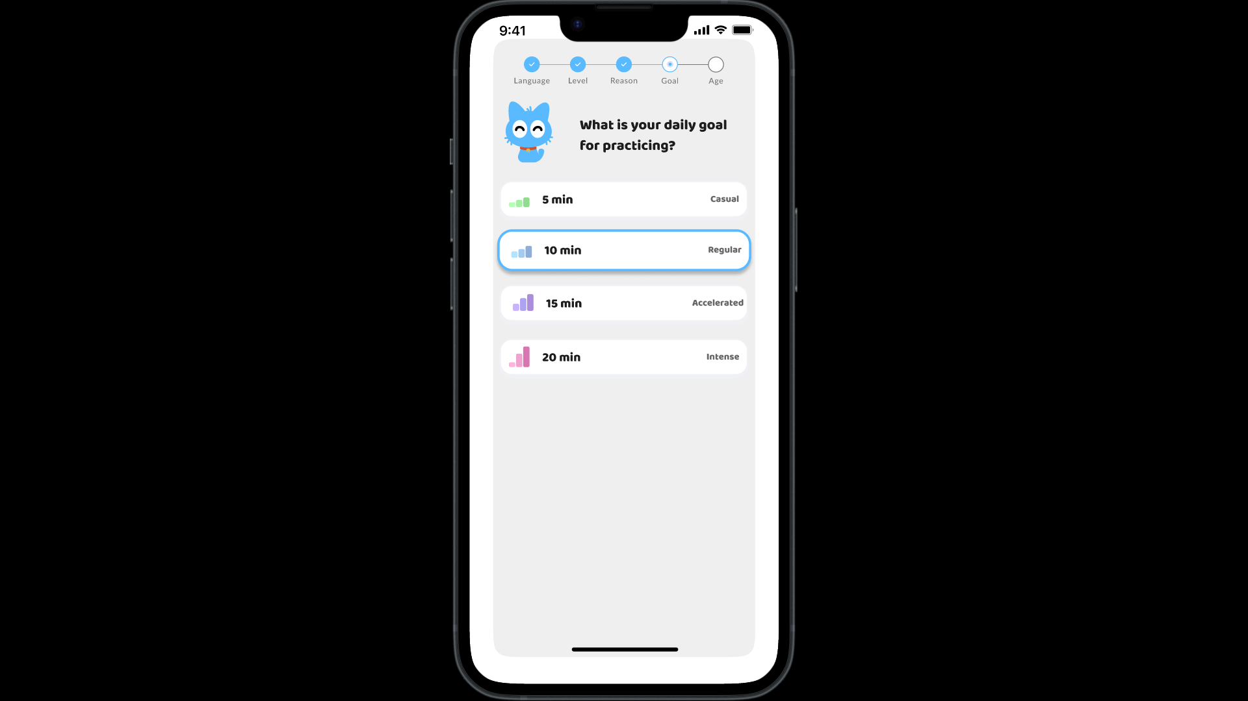

After choosing the goal, the user’s age is asked to understand the user better in terms of learning capacity.

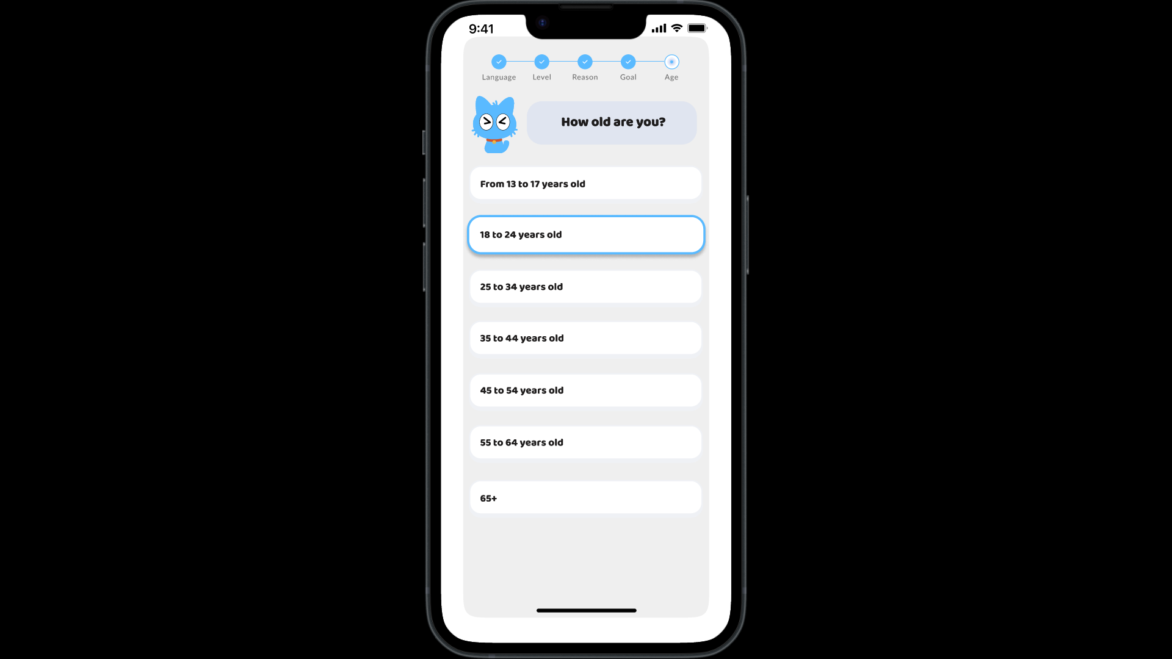

After choosing the age, the user’s inputs are processed.

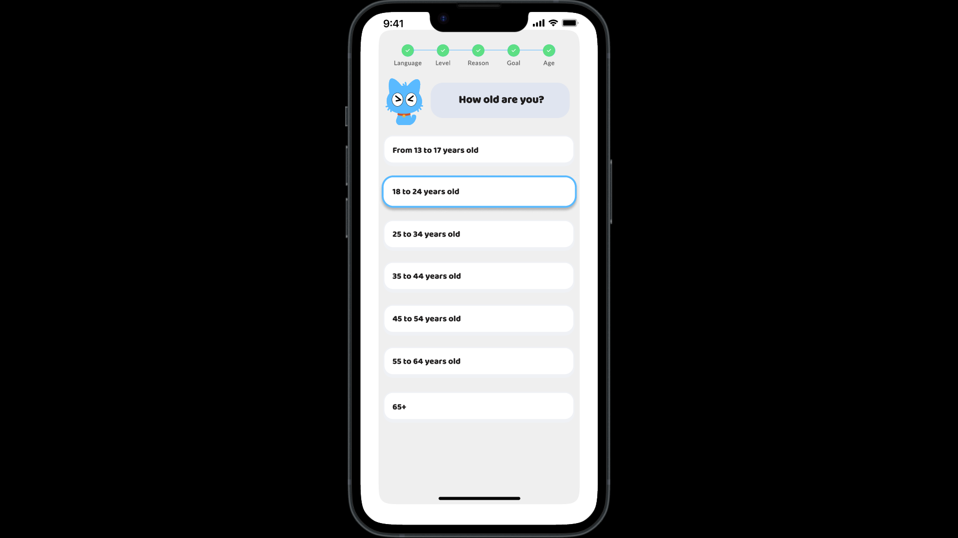

An intermediate screen that would show the user their progress and navigate the user to the home screen.

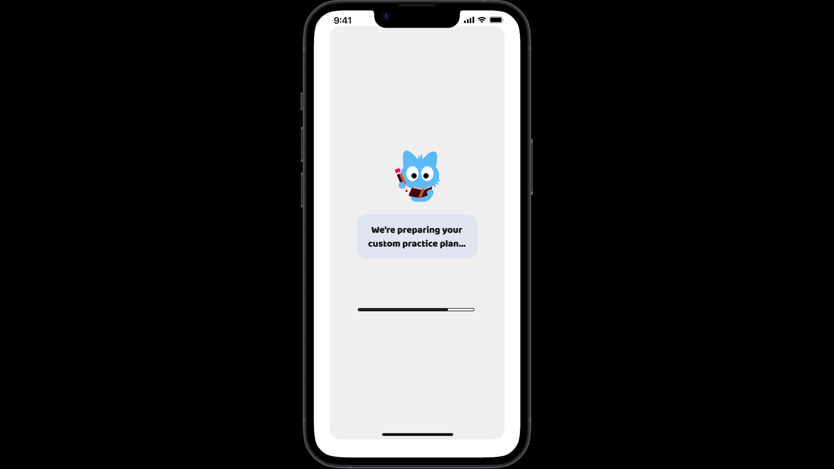

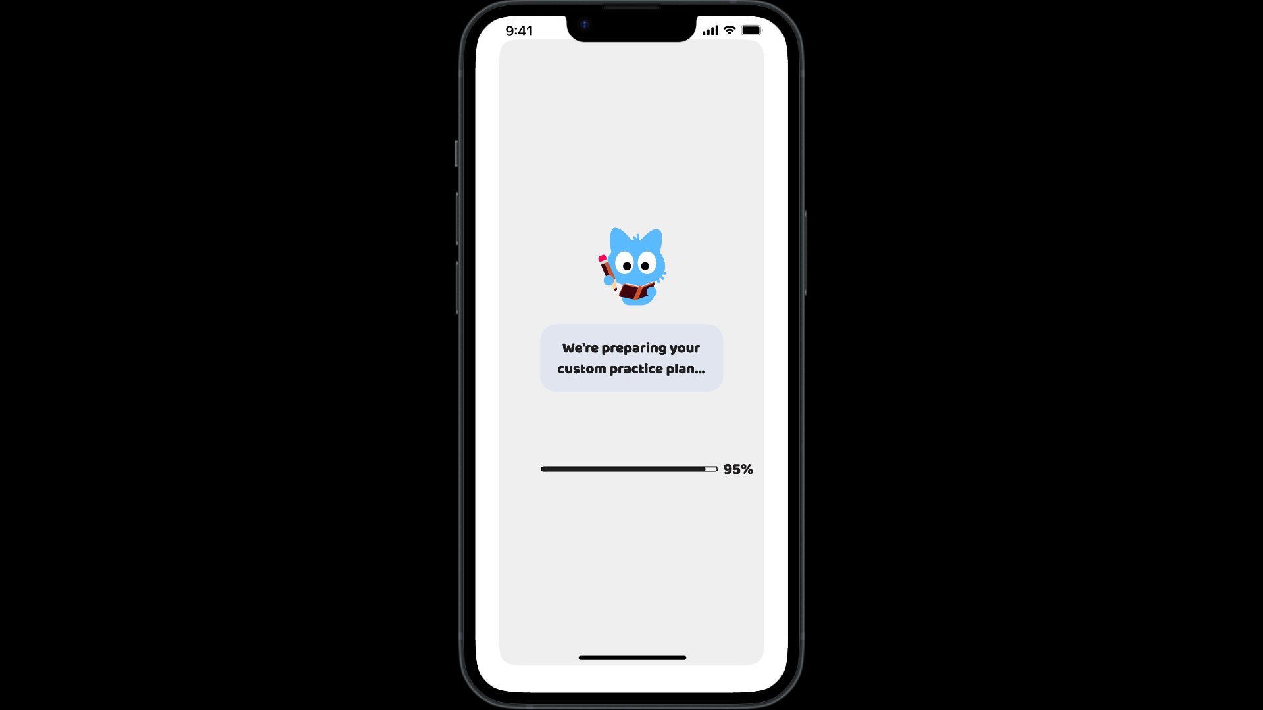

The user is directed to the “Home” page.

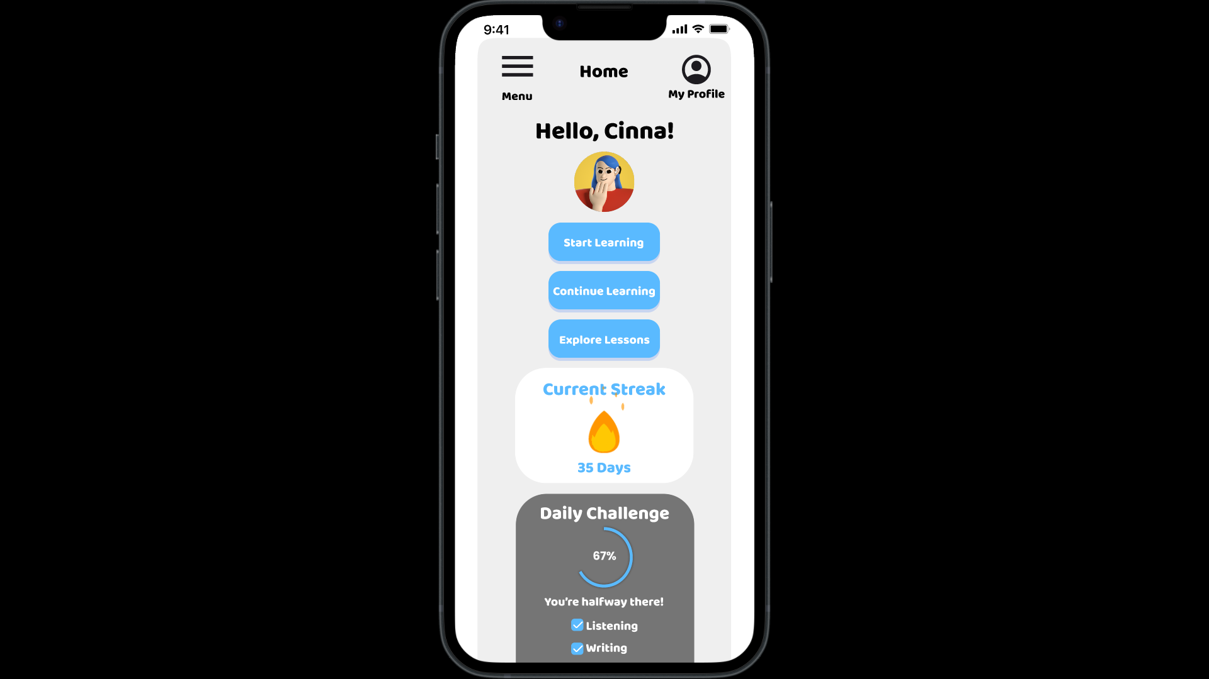

1. Sign-in Tools:

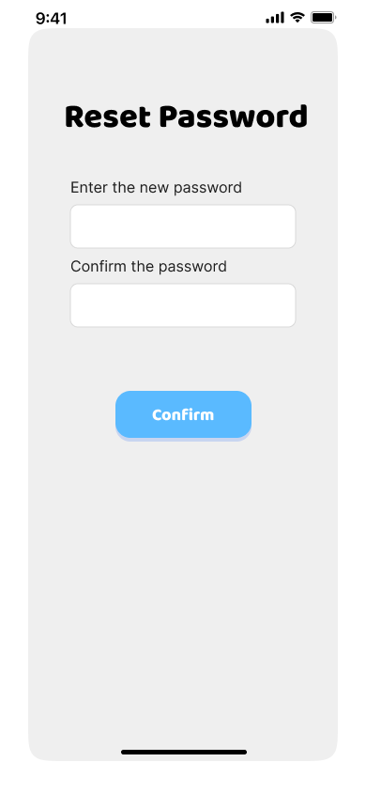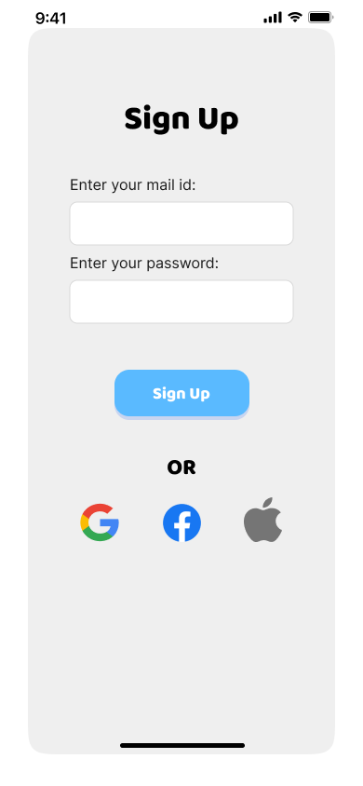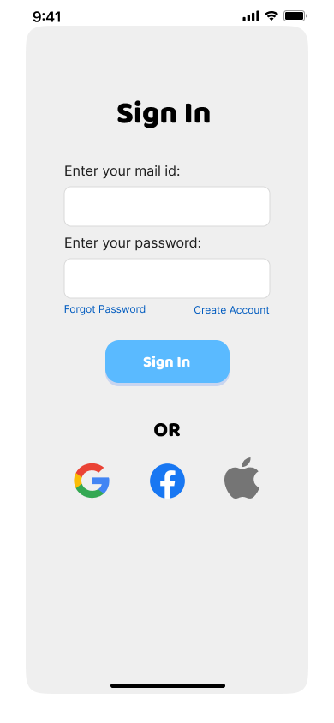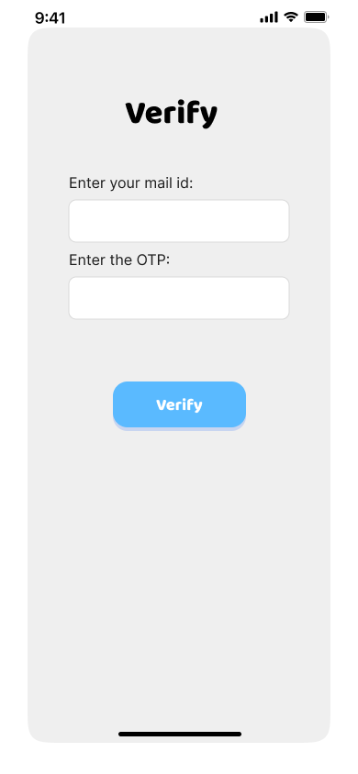The sign-in page offers a user-friendly experience with options to “Sign in with Google”, “Sign in with Facebook” and “Sign in with Apple”. This allows users to start using the app without the need for lengthy sign-up forms.

The first screen a user encounters when starting the app.

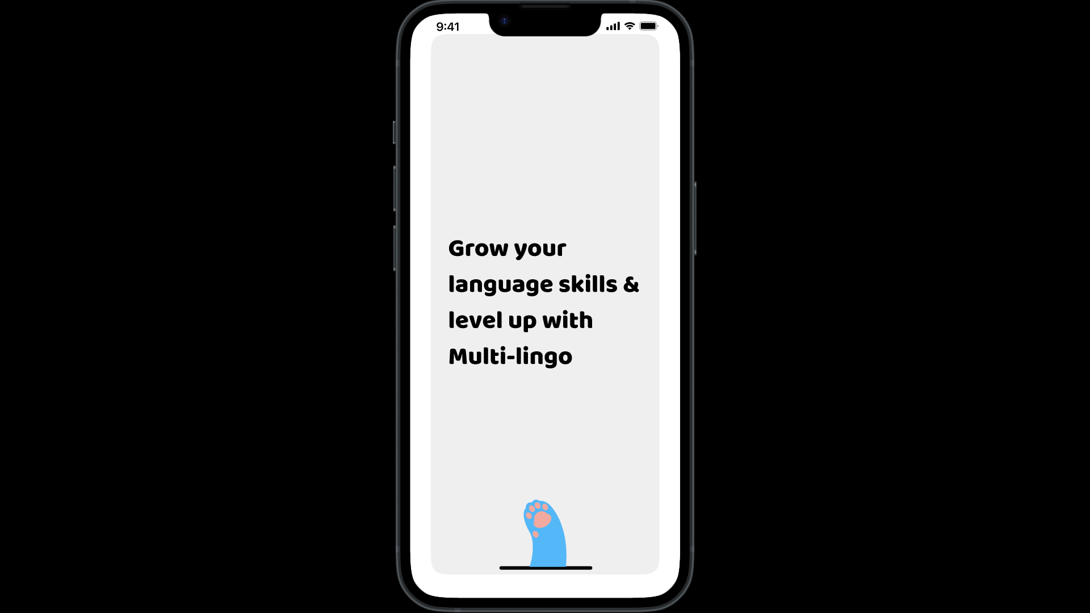

The user has to sign in to their account to retain their progress or keep a track of it.

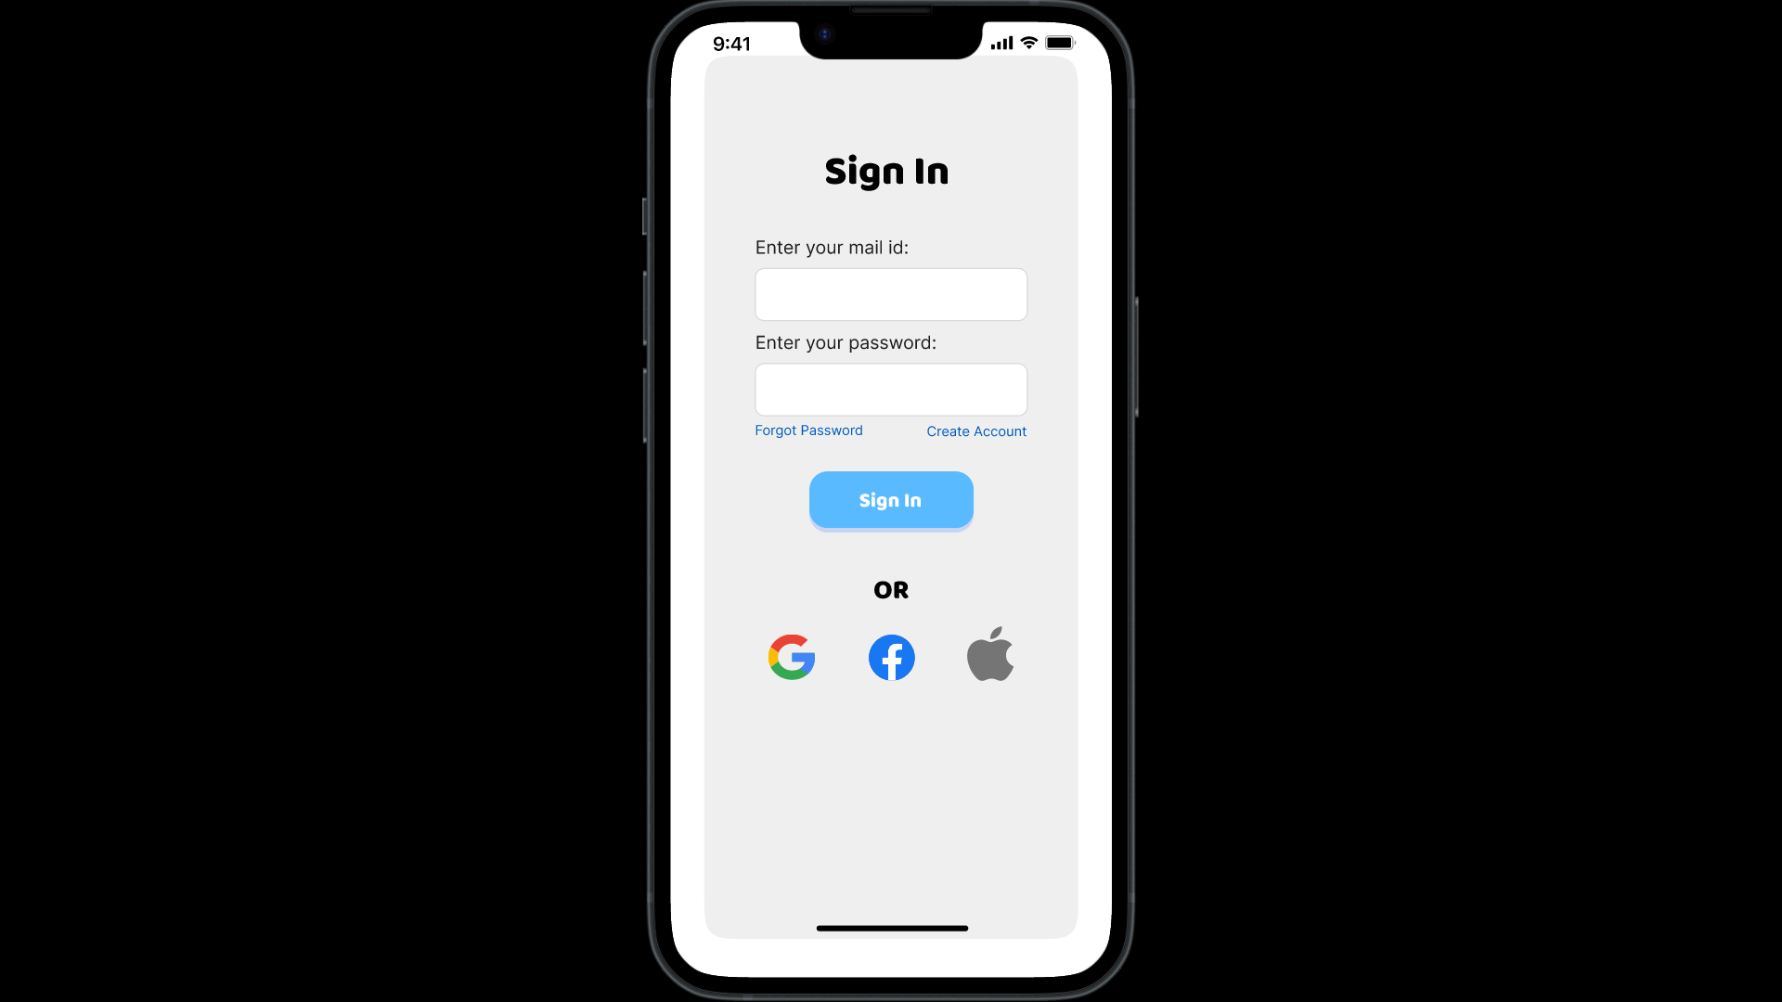

If it is a first time user, they will have to sign up to create a new account. On clicking “Create Account” the user is navigated to the following screen.

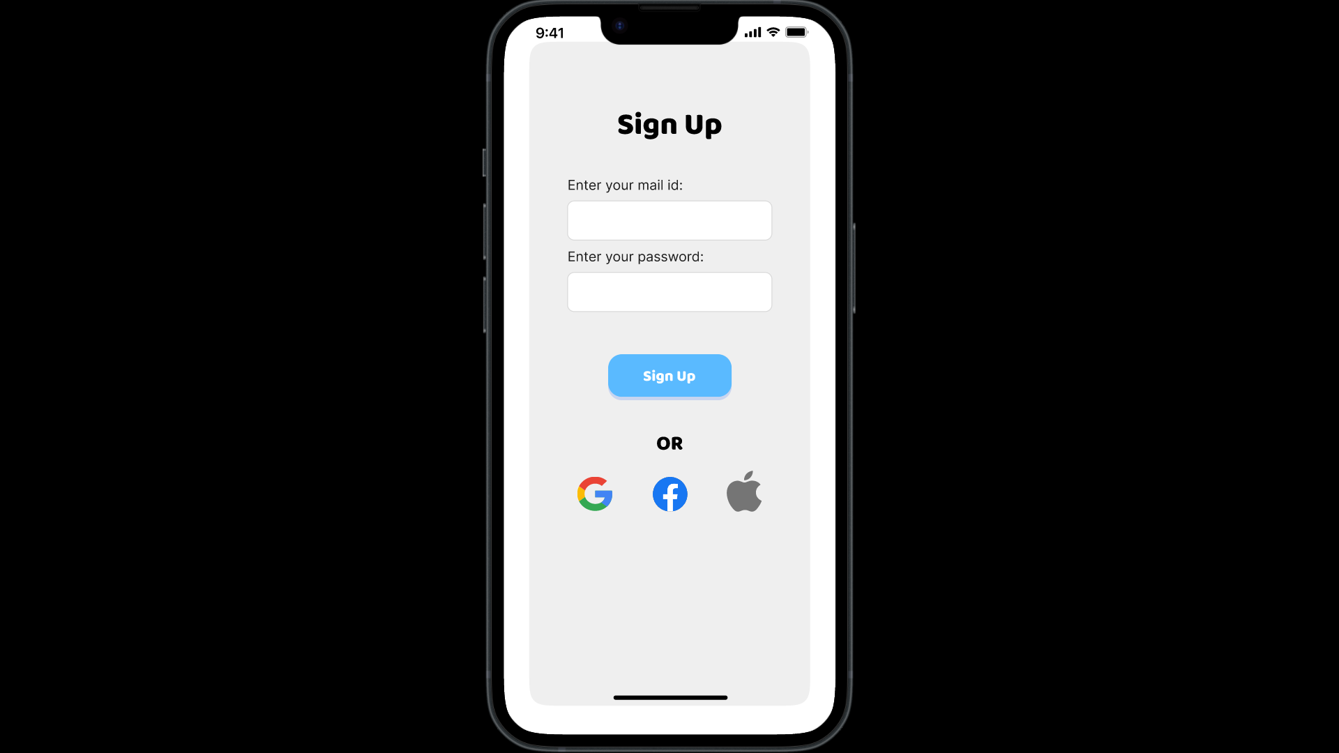

After the user signs themselves up, they have to sign in again to proceed.



If the user has forgotten their password, they will have to verify themselves through an OTP that will be sent to their entered mail.

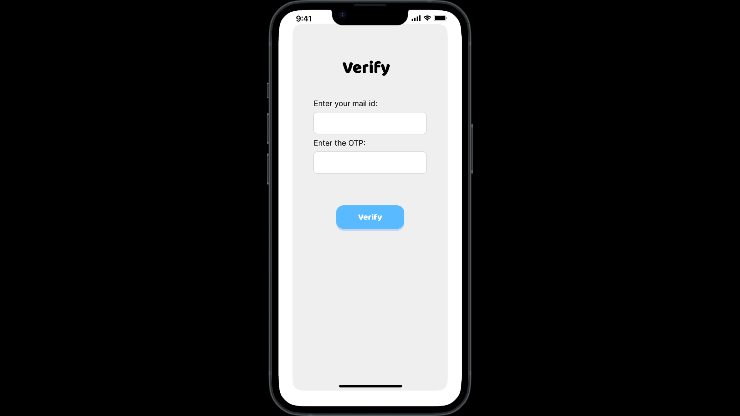

After verification, they can enter the new password and proceed.

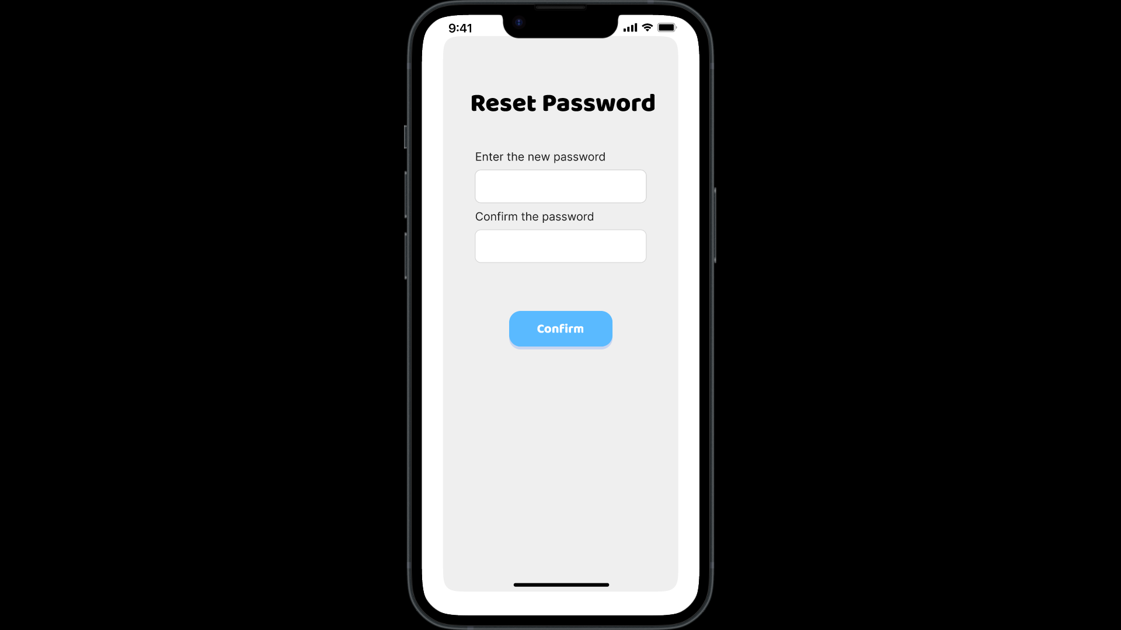

The user will have to sign in again and then the user can start using the app.



**Analysis:**

|  |  |
| --- | --- |
| **Name of the pattern/model** | Clear Entry Points |
| **Selection Criteria** | To make the app welcoming and simple for new users |
| **Benefits of using the pattern/model** | Enhances user onboarding and reduces confusion |
| **Conclusion** | It helps users begin their learning journey smoothly |

|  |  |
| --- | --- |
| **Name of the pattern/model** | Modal Panel |
| **Selection Criteria** | To keep users updated on their progress |
| **Benefits of using the pattern/model** | Maintains user engagement by providing feedback without requiring navigation |
| **Conclusion** | It supports continuous engagement with minimal interruptions |

|  |  |
| --- | --- |
| **Name of the pattern/model** | Escape Hatch |
| **Selection Criteria** | Offers a way for users to exit longer activities while saving progress |
| **Benefits of using the pattern/model** | Gives users control and flexibility over their learning sessions |
| **Conclusion** | It ensures users can manage their time effectively |

|  |  |
| --- | --- |
| **Name of the pattern/model** | Sequence Map |
| **Selection Criteria** | Helps users understand their progress through a process |
| **Benefits of using the pattern/model** | Allows users to track their progress through setup steps |
| **Conclusion** | It makes the process more structured and less overwhelming |

|  |  |
| --- | --- |
| **Name of the pattern/model** | Sign-in Tools |
| **Selection Criteria** | Simplifies the user registration process |
| **Benefits of using the pattern/model** | Ensures users can start quickly, which improves user retention |
| **Conclusion** | It makes the app accessible to a wider range of users |

**(Extend the table for all patterns/models you use)**

**Synthesis:**

**Explain the effect of the wireframes in your app’s usability.**

The wireframes aim to enhance the usability of the “Language Learn” app by offering clear navigation and keeping users motivated. Features like Clear Entry Points and the Sequence Map ensure users know where they are in the process, while the Modal Panels and Escape Hatch provide flexibility and positive reinforcement. Sign-in Tools make starting with the app easy.

**Figma Link:**

[**https://www.figma.com/design/HQikko0ouaB0IFihLg0vW5/Language-Learn-(Copy)?node-id=0-1&t=Ear0N5sBVCOqNfFY-1**](https://www.figma.com/design/HQikko0ouaB0IFihLg0vW5/Language-Learn-(Copy)?node-id=0-1&t=Ear0N5sBVCOqNfFY-1)